The Basics of Supply: Guided Notes
Supply refers to:

The Law of Supply:

Why are price and quantity supplied positively (directly) related?

Supply Curve

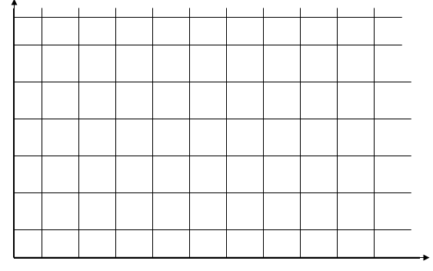
Movement Along a Supply Curve

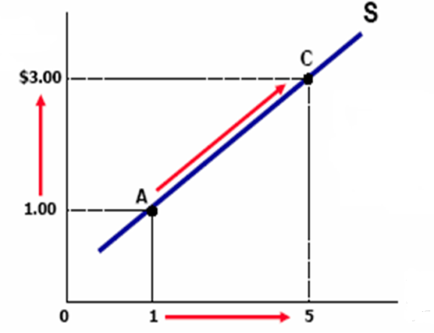

Determinants of Supply:
Factors That Can Shift the Supply Curve Are Changes in:

The Basics of Supply: Guided Notes (continued)
Practice Problems:
1. What would happen to the supply of pizza if more businesses enter the pizza market?
- Determinant?

- Increase or decrease in supply?

2. What would happen to the supply of Nike shoes if there is an increase in the cost of rubber?
- Determinant?

- Increase or decrease in supply?

3. A new technology is invented that allows factories to produce energy drinks more efficiently.
- Determinant?

- Increase or decrease in supply?

  - A company that makes video games pays their workers the minimum wage. The government passes a law that increases the minimum wage businesses can pay workers.

- Determinant?

- Increase or decrease in supply?

5. A computer company finds out a competitor is planning to sell a new and improved type of computer.
- Determinant?

- Increase or decrease in supply?

Movement Along a Supply Curve Means…

A Shift of the Supply Curve Means….

The Basics of Supply: Guided Notes (continued)
Putting the Story and the Picture Together
Original Prices New Prices
Quantity supplied of pizza per week (by millions) | Price of pizza
9 | $3.00
14 | $6.00
19 | $9.00
25 | $12.00
30 | $15.00
--- | $0.00
Quantity supplied of pizza per week (by millions) | Price of pizza
15 | $3.00
20 | $6.00
25 | $9.00
30 | $12.00
35 | $15.00
--- | $0.00

