Graphing Changes in Demand
For each scenario, you will graph the change in demand. You are to label the X and Y axis correctly and draw an original demand curve. On the same graph, draw the new demand curve based on the scenario. Label the original demand curve D1 and the new demand curve D2. Lastly, select the determinant that helped you to decide what happened to demand.
- Officials at the most recent National Association of Broadcasters Exposition say that little by little, consumers are learning about high-definition television’s clearer picture and better sound quality. What will happen to the demand of HDTV?  Determinant: _______________________________  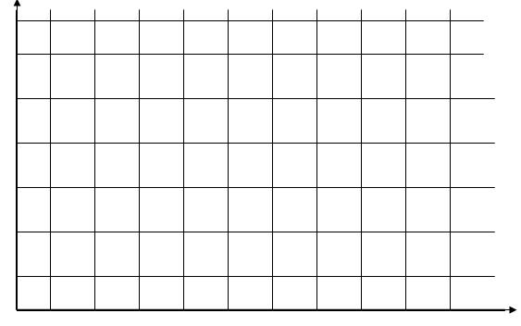 | - New York City recently passed an anti-dog-liter law that mandated that owners had to follow their dogs around the city with scoopers and plastic bags. The law raised the cost of owning a dog. What will happen to the demand of dogs as a result of this law?  Determinant: _______________________________
- In the mid-1990s, there were 2.7 million pay phones across the country. However, due to lower prices, by the end of the decade the number of cell phone users began to rise. What will happen to the demand of pay phones by 2010?  Determinant: _______________________________ | - Super Bowl Sunday is the biggest single day of avocado consumption in the United States, thanks to the serving up of bowls of the zesty green dip known as guacamole. Super Bowl Sunday is two weeks away, what will happen to the demand of avocados today?  Determinant: _______________________________

